
Clinic Data Integration and Analysis
USING SSIS & POWER BI


Prepared by:
Salma sherif
Sama wael
Sedra abelrahman
Bassant adel
Ehsan abdelmoniem
Ahmed Dawood
Mustafa Mahmoud

Table of Contents

1. Introduction 2
2. Dataset Overview 2
3. ETL Process using SSIS 3
4. Power Query Transformations 4
5. Power BI Dashboard Overview 4
6. Charts Analysis 5
7. Enhancements and Interactivity Features 9
8. Conclusions & Recommendations 10
Appendix: 10

1. Introduction
This document presents the complete data processing and visualization flow for a clinic dataset. The project integrates data from multiple sources, applies transformations in SQL Server Data Tools (SSDT), and visualizes insights through an interactive Power BI dashboard.

2. Dataset Overview
The dataset was created using a Python script and split into three different file formats:
- CSV
- Excel
- Flat file
Columns included:
- ID
- Date
- Patient Name
- Age
- Gender
- Diagnosis
- Treatment
- Doctor
- Visit Cost
- Lab Results
- Prescription

3. ETL Process using SSIS
- Three file sources were loaded into SSIS using different Data Flow Tasks.
- Date values were inconsistent (formats like d/mm/yyyy and dd/mm/yyyy), which required transformation.
Steps Followed:
- Conditional Split
  - Split rows based on length of date string:
    - Case 9: d/mm/yyyy
    - Case 10: dd/mm/yyyy
- Derived Column
  - Standardized both formats into YYYY-MM-DD:
    - Case 9: SUBSTRING(Date,6,4) + "-" + SUBSTRING(Date,3,2) + "-0" + SUBSTRING(Date,1,1)
    - Case 10: SUBSTRING(Date,7,4) + "-" + SUBSTRING(Date,4,2) + "-" + SUBSTRING(Date,1,2)
- Data Conversion
  - Applied correct data types and cleaned column names.
- Union All
  - Merged results of different branches into one stream.
- OLE DB Destination
  - Final table created in a SQL Server database named clinic, with the integrated data stored in a table named c1.

4. Power Query Transformations
- Connected to the SQL table c1 in Power BI.
- Applied the following transformations:
  - Renamed columns
  - Changed data types (especially Date and Cost)
  - Removed duplicates
  - Filtered null values

5. Power BI Dashboard Overview
The dashboard consists of:
- 9 Visual Charts
- 3 Slicers: Gender, Diagnosis, Doctor
- Reset Filters Button (Bookmark)
- Cards with KPIs
- Enhanced layout and background formatting

6. Charts Analysis

Chart 1: Pie Chart – Patients by Gender
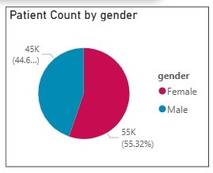
- Insight: Balanced distribution of male and female patients.
- Recommendation: No significant bias found. Gender-based analysis can be refined with age.

Chart 2: Stacked Column – Patient Count by Gender & Diagnosis
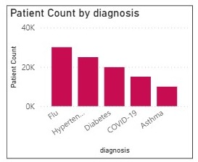
- Insight: Visualizes prevalence of diagnoses split by gender.
- Recommendation: Tailor treatments based on common gender-specific diagnoses.

Chart 3: Clustered Column – Average Age by Diagnosis
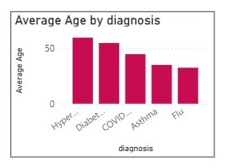
- Insight: Shows which conditions are common in specific age groups.
- Recommendation: Adjust screening efforts by age.

Chart 4: Line Chart – Visit Cost by Age
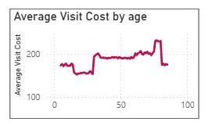
- Insight: Older patients generally incur higher visit costs.
- Recommendation: Consider senior-care cost management.

Chart 5: Donut Chart – Patient Name by Diagnosis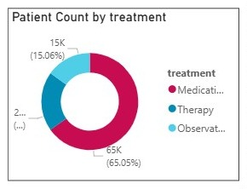
- Insight: Reveals how often each patient is associated with each diagnosis.
- Recommendation: Identify chronic or recurring cases.

Chart 6: Matrix – Diagnosis by Doctor and Patient Count
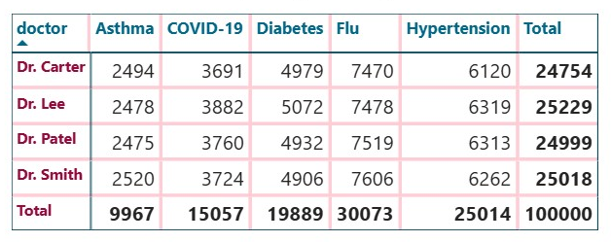
- Insight: Shows which doctors handle more cases of specific diagnoses.
- Recommendation: Balance workload and specialize doctor assignments.

Chart 7: Card KPIs – Total Patients / Total Cost / Total Diagnoses
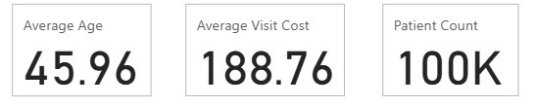
- Insight: Summary of key statistics.
- Recommendation: Monitor these values monthly.
Chart 8: Stacked Bar Chart – Patient Count by Doctor & Gender
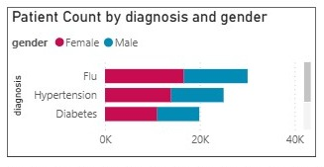
- Insight: Gender distribution among doctor workloads.
- Recommendation: Validate gender-specific preferences or referral trends.

Chart 10: Clustered Bar Chart – Count of Patients by Diagnosis
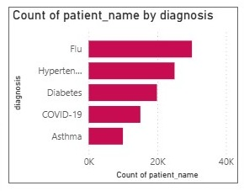
- Insight:
Flu is the most common diagnosis, followed by Hypertension and Diabetes, indicating a high prevalence of seasonal and chronic illnesses.
- Recommendation:
Allocate more resources to manage these conditions and launch awareness campaigns to reduce their recurrence.

7. Enhancements and Interactivity Features
- Slicers:
  - Gender
  - Doctor
  - Diagnosis
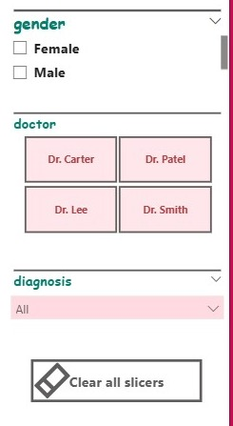
- Reset Filter Button: Implemented using Bookmarks and Selection Pane.
- KPI Cards: Added rounded corners and drop shadows for professional appearance.
- Custom Background: Applied to maintain visual consistency.
- Header Title: Clinic Patient Analytics Dashboard

8. Conclusions & Recommendations
- SSIS allowed robust ETL processing and transformation of unstructured and inconsistent data.
- Power BI provided interactive visuals for deriving useful insights for clinic operations.
- Use the dashboard for regular performance tracking and decision making.

9. Appendix

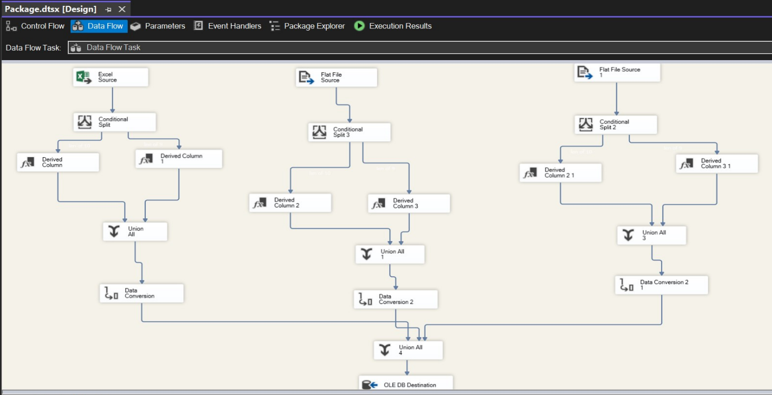
Figure 1 SSIS Package showing Conditional Split and Derived Column
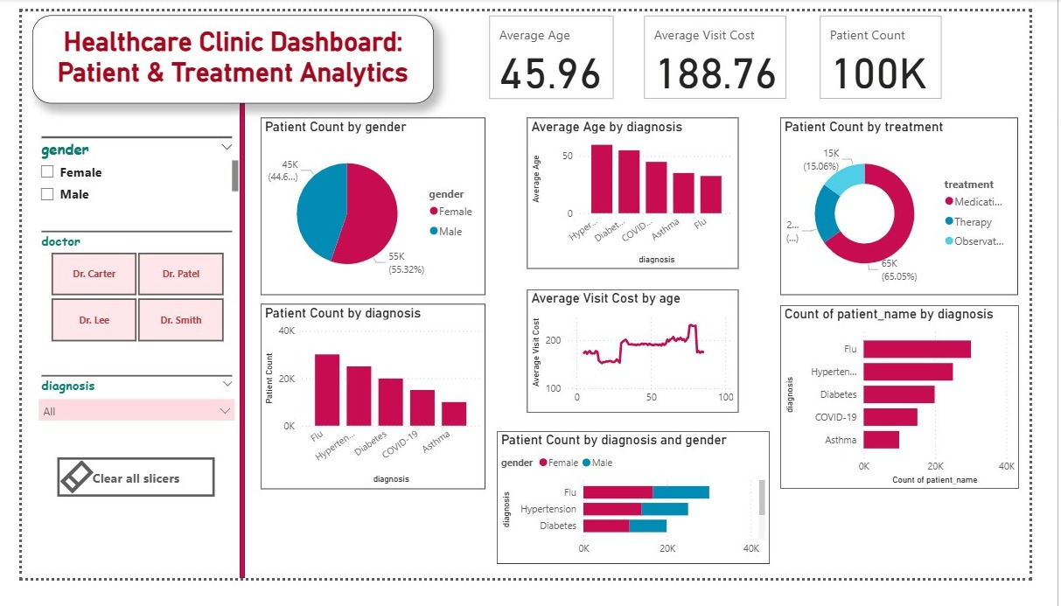
Figure 2 Final Power BI Dashboard – Patient Insights

